**The response of the rider’s body to roll oscillations of two wheeled vehicles; experimental tests**

Dear 3mE student,

We are conducting experiments as part of a research study to increase our understanding of how the riders body respond to rotational and translational oscillations when riding a bicycle. More specific, we will try to identify the mechanical impedance and resonance of the rider body when subject to these oscillations. As a participant you will be requested to wear a safety harness and sit on the bicycle mock up as shown in fig.1 below.

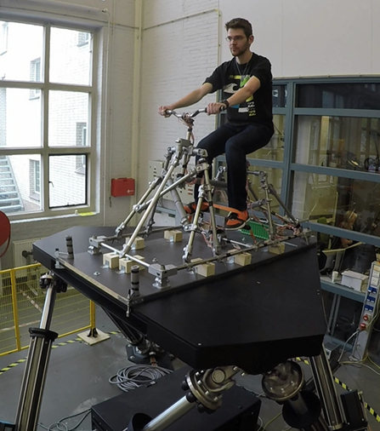

*Fig.1 Bicycle mock up mounted in the top of a hexapod*

The experiment takes around 30 minutes . There is no compensation for participating in this study. However, your participation will be a valuable addition to our research and findings could lead to greater public understanding of human machine interaction. If you are willing to participate please send us an email. Suggest a day and time that suits you and I'll do my best to be available. If you have any questions please do not hesitate to ask.

Leader of the project: **George Dialynas**: <g.dialynas@tudelft.nl>

Intern**: Toni Prats:** <Gtakula07@gmail.com>